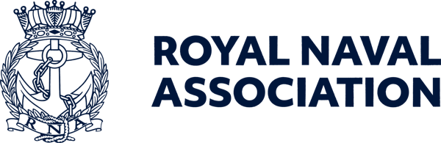

Semaphore Short Friday 25 September 2026

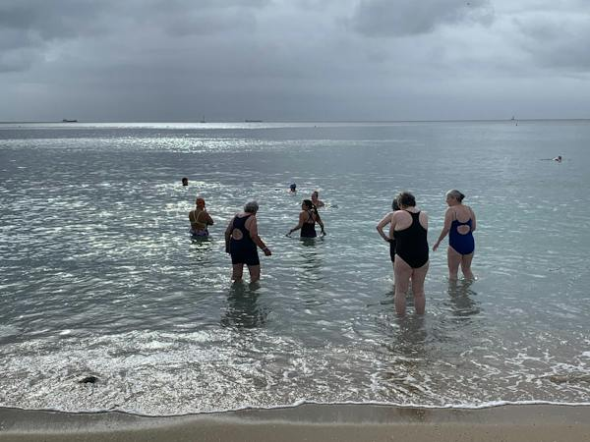

Taking time out

A group of RNA shipmates enjoyed a weekend in Falmouth taking a break from the pressures of their everyday lives.
They spent time with other women who understood their situations and enjoyed some much-needed space to reconnect, recharge and simply have fun.
For more details and pictures of the retreat, organised by the Association, see next Friday’s Semaphore Circular.

Remembrance parade on Whitehall

Spaces have become available for the RNA contingent marching to the Cenotaph on Whitehall in London on Remembrance Sunday (8 November).
If you would like to take up one of the places please contact Jon Boreham before 27 September on ams@rnassoc.org
Remember, if you register through the RNA you will be expected to march with the RNA contingent.
If you have already registered with us, please make sure that you respond to the email which you should have received from the Royal British Legion – failure to do so will mean that you will not be able to take part in the parade.
After the parade, members are invited to a sandwich lunch reception at the Civil Service Club at 13-15 Great Scotland Yard, but spaces are strictly limited and will be allocated on a first-come, first-served basis.

Free rail travel for Remembrance ceremonies

Bereaved military family members will be able to travel by train free of charge this Remembrance weekend (7 to 8 November), helping them attend memorial services and commemorative events to honour loved ones who died while serving in the Armed Forces.
For the first time, one next of kin of a service person who died while serving will be able to travel free of charge on National Rail services to attend Remembrance weekend events.
The move builds on the existing free travel offer for serving personnel and veterans, giving people breathing space and ensuring travel costs are not a barrier for families taking part in remembrance and reflection.
Eligible family members wishing to take up the offer have until 16 October to apply for a free ticket through the Defence Medical Welfare Service.
For more details see https://tinyurl.com/y42k59m9 and watch our social media channels and Semaphore publications for more details of Remembrance ceremony transport arrangements over the coming weeks.

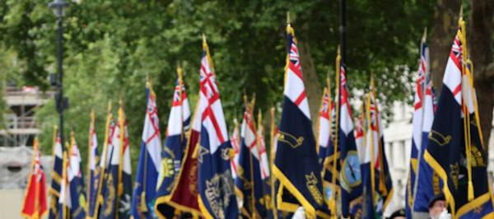

Call for standard bearers

Standard bearers are requested to attend the funeral of Royal Navy submariner Lt Richard Perkins at 1100 next Wednesday (30 September) at Hither Green Crematorium, Lewisham, London (SE6 1TP).
If you can attend, please inform RNA Central Office on wws@rnassoc.org.

Remembrance and Comradeship Grants

Could your RNA Branch benefit from funding for a remembrance or comradeship activity?
Royal Navy & Royal Marines Charity (RNRMC) Remembrance and Comradeship Grants can help eligible RNA Branches and other Naval and Marines organisations fund activities that bring people together, support remembrance and strengthen comradeship, while helping to reduce loneliness and social isolation.
Funding can contribute towards:
* Remembrance and commemorative events
* Travel to national remembrance events
* Branch and community gatherings
* Venue hire, refreshments and promotion.
Your application should explain how the activity will benefit your community and help people connect with others and access support.
Find out more and apply: https://www.rnrmc.org.uk/remembrancegrants.



Get ready for Uckers glory

The RNA World Uckers Championships takes place at the Royal Maritime Hotel in Portsmouth on Saturday of next week (3 October) – and glory beckons if you are willing to try your hand!
Registration on the day will be held between 0900 to 1000, and players of any standard, from novice to expert, are welcome to enter – there are singles and doubles competitions.
The first roll of the dice will be at 0930, and spectators are welcome. Refreshments will be available.
To help us plan, please register your interest by emailing Milly at ceo-ea@rnassoc.org with your name, contact details and whether you're entering solo or with a teammate.

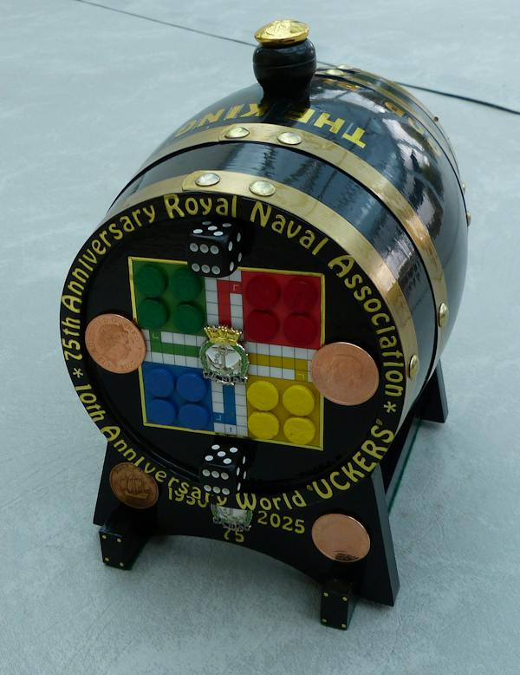

Roll out the barrel

And talking of the Championships, a unique rum barrel (pictured above) created by Shipmate Wally Blagden, is available through an auction which ends on the day of the competition, with bidding currently standing at £500.
Money raised will be donated to the RNA Central Charity Fund.
The current highest bidder, who wishes to remain anonymous, has expressed an interest in presenting the barrel to the Association to auction once more at a Trafalgar Night dinner.
The 2.5 litre barrel includes several special coins, including a King George VI 1950 halfpenny (representing the RNA’s 75 anniversary last year), a 1970 Galleon halfpenny (for the 56th anniversary of Black Tot Day), and a King Charles III 2026 £5 crown, marking 500 years of the crown coin.
Bidding will close on 3 October to coincide with the World Uckers Championships.
If you would like to make a bid, you can send it to RNA Central Office at ceo-ea@rnassoc.org and we will pass it on to Wally.



Army v Navy rugby tickets now available

RNA members can now apply for tickets for the Army v Navy rugby double header at Twickenham on Saturday 1 May next year.
The Association has an allocation of 1,350 tickets exclusively reserved for RNA members. For 2027, tickets will be available through a dedicated
members-only booking link, which will be sent directly to members who request tickets.
Please note: To protect our allocation, this booking link must remain confidential and must not be shared with anyone else.
The RNA experience provides:
- A dedicated RNA seating
- Exclusive access to our private clubhouse bar.
Enjoy the day alongside fellow RNA members, friends and family.
The rugby kicks off at 1400 for the senior men’s clash, with the women’s match following at 1645.
If you are bringing a crowd, purchasers of ten or more tickets will receive a ten per cent discount on their booking.
Contact us to request your members-only booking link and secure your place before our allocation is exhausted.
Email Milly on ceo-ea@rnassoc.org

We have moved (temporarily)

Just a reminder that the Central Office team has vacated Lanyard House for the next few weeks, and staff are working from a smaller office elsewhere in Portsmouth Naval Base or from home while essential maintenance is carried out on the building.
You can contact the team on 07889 059025 during office hours, or use email addresses as before.
Keep an eye on our social media channels and the Semaphore publications for further information on the maintenance programme and our return to Lanyard House.

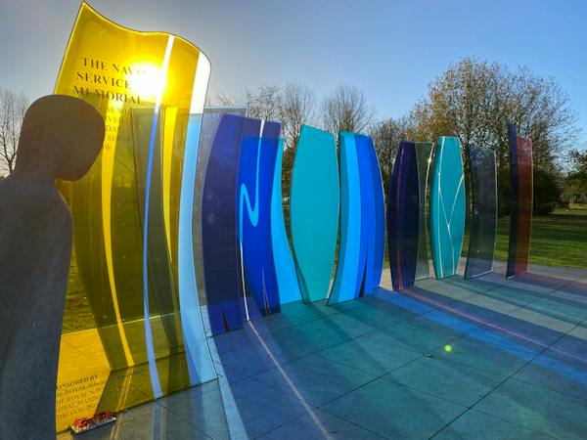

Fundraising continues for Naval Service Memorial

We are still seeking funds to help preserve and maintain the stunning Naval Service Memorial at the National Memorial Arboretum.
The appeal is aiming to raise £75,000 – £15,000 for essential repairs and £60,000 to cover future maintenance and upkeep costs.
Part of this will ensure the glass panel seals are updated to withstand the wear and tear of the Staffordshire weather using techniques which were not available at the time it was created 12 years ago..
Sadly, one of the memorial’s eye-catching glass panes has developed water ingress at its upper edge. To prevent further deterioration and to protect the structure as a whole, remedial work is required to repair the affected pane and to install protective seals across all panes
The monument stands as a powerful tribute to the service and sacrifice of the Royal Navy, Royal Marines, and associated services.
We strongly encourage all those with an interest in Naval history, service, and remembrance to visit the National Memorial Arboretum, at Alrewas near Burton, and see the memorial for themselves.
Any contribution, large or small, will help ensure the Naval Service Memorial remains a fitting and dignified place of remembrance for all future visitors.
You can donate using this link: https://www.justgiving.com/campaign/navalservicememorial

RNA diaries now on sale

The Royal Naval Association 2027 diary is now on sale.
The diary costs £8.50 without postage, or £10 including postage and packing.
To order your copy please contact Jon B on ams@rnassoc.org or Kathryn on dams@rnassoc.org.

Welfare training session

The next training session for RNA Welfare & Wellbeing Volunteers covers the basics, DBS and GDPR, helping volunteers support our people safely and effectively.
The session is scheduled for Saturday 3 October from 10am–midday online using Zoom – the link is at https://us02web.zoom.us/j/89582756392?pwd=Cp3HnJrbRN20wV2hdrm8zZT7ZuaP6S.1

  Shop for the Association
  You could turn your everyday shopping into support for the RNA without spending an extra penny.
  Whether you're buying gifts, booking a holiday, or ordering your weekly essentials online, you could be raising free donations for the Royal Naval Association through easyfundraising.
  Simply sign up, select the RNA as your chosen charity, and participating retailers will donate on your behalf at no additional cost to you.
  It’s free to join, there are thousands of retailers involved,
  

and every donation helps support members, veterans, and their families
Start fundraising the easy way – use this link: https://tinyurl.com/54b34d42 or use the QR code (above right). You just need to click ‘Support this Cause’, create a free account, and start shopping with participating retailers via the website, app or browser extension.
Once you’re registered, donations will be automatically generated whenever you make eligible purchases.

 |  |  |  |  |  |  |  |  |  |  | 

